

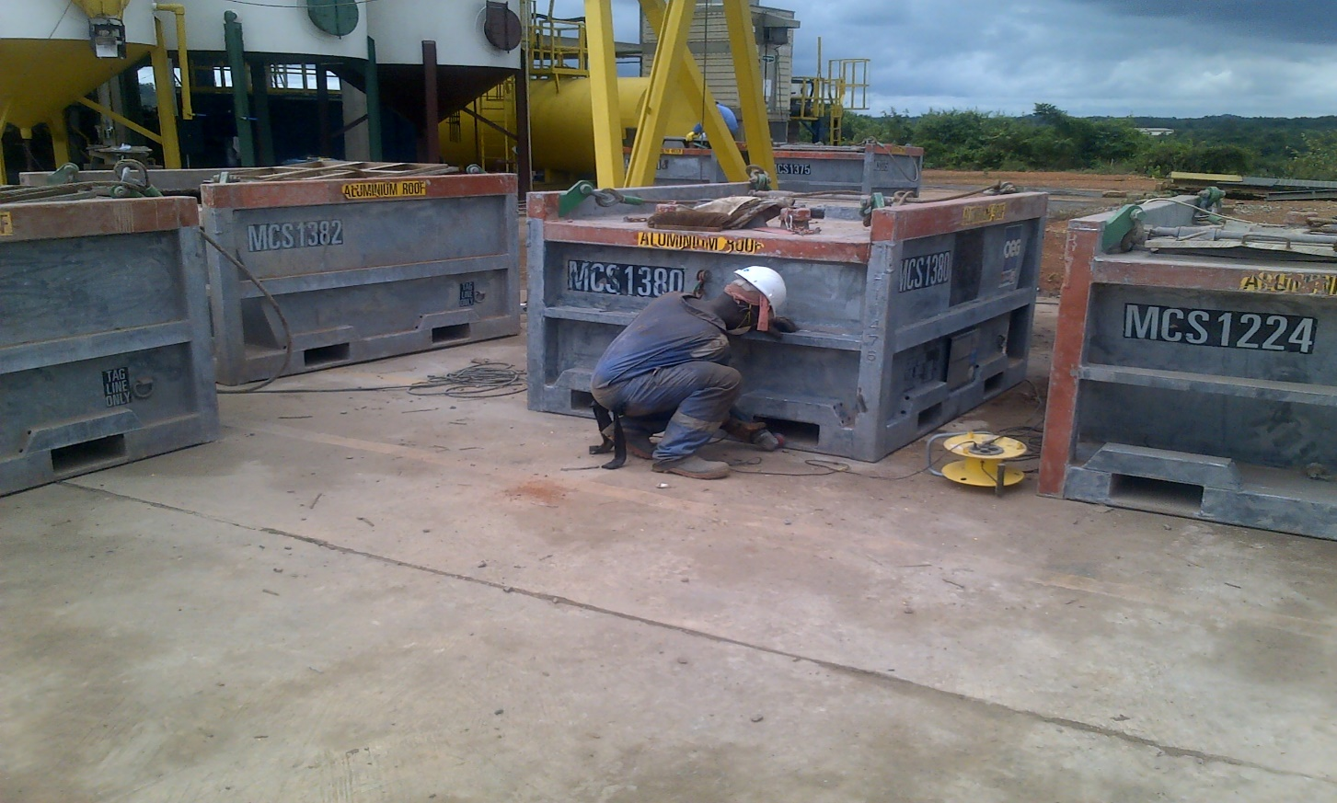

Semi-annual HSE Performance Report

**2016**

Table of Contents

i. Message from Senior HSE Officer 3

1. Introduction 3

2. Our certificates 4

3. Goals and targets for 2016 4

4. HSE Performance 5

4.1. Man days and Hours. 5

4.2. Lagging Indicators 6

4.3. Leading Indicators 7

4.3.1. Workplace Inspection 8

4.3.3. Monthly Training 10

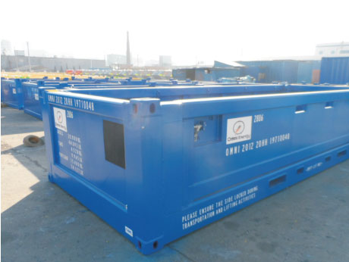

4.3.4. Job Specific Training 11

4.3.5. Toolbox Talks Participation 11

4.3.6. Hazard reporting 12

4.4. Accident and Incident Rate 12

5. Environment 14

6. Health and Safety Communication 15

6.1. Safety induction 15

6.2. Peer group discussions 15

6.3. Notices and Posters 15

6.4. Safety signs 15

6.5. Toolbox talks/Safety briefings 16

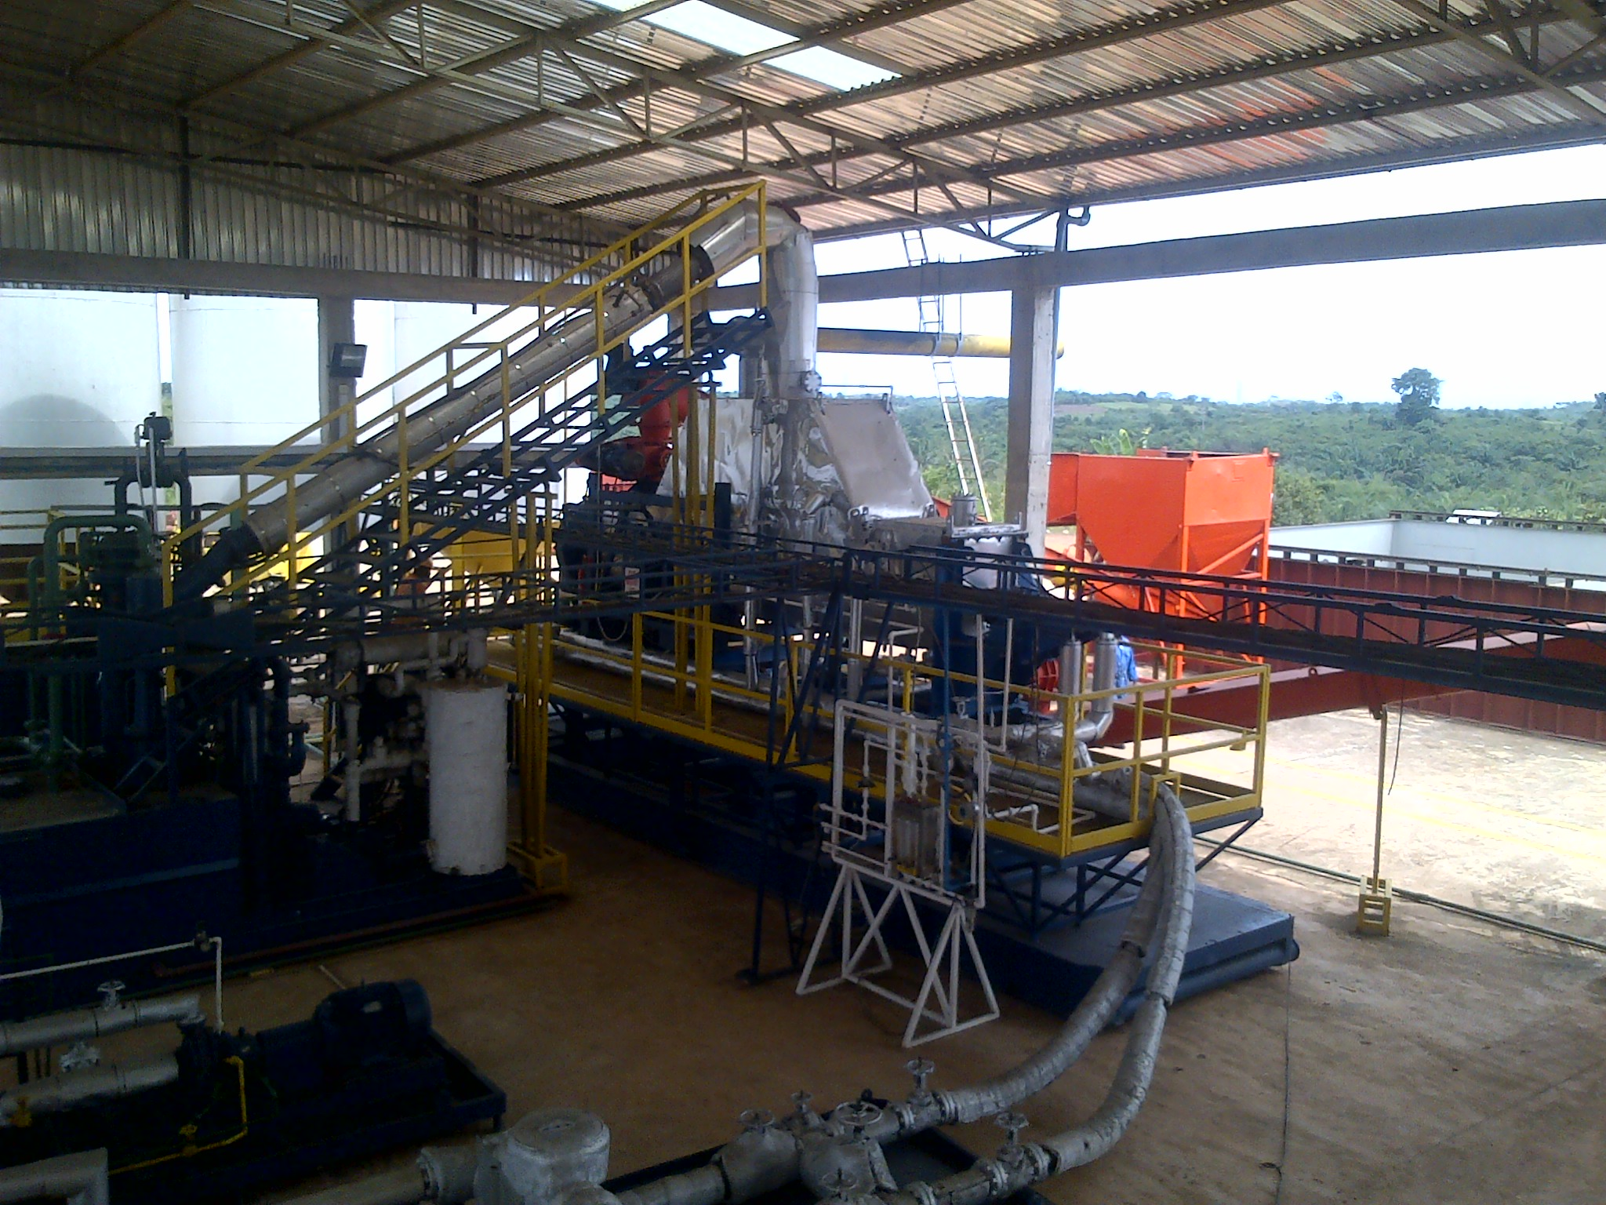

1. **Message from HSE Officer**

Omni Energy’s chief priority is to ensure the safety and well-being of every employee and those who may be affected by our activities.

We have maintained an over-arching framework to ensure the health and safety of all workers at all our branches across Sub-Saharan Africa

The underlying, motivational factor of the HSE department is the principle of “Zero accident and zero environmental incident”.

We are convinced that this HSE report will give a clear and vivid insight into our constantly evolving and improving performance.

**Selorm Alfred Ametewee**

**Health, Safety and Environment Officer**

1. **Introduction**

This semi annual report summarises key aspects of our health and safety (H&S) performance and signifcant areas of activity for the first half of the year, 2016.

However, the report focuses less on enviromental activities since that will be captured in the Annual Environmental Report to be submitted to the EPA.

The HSE department continues to demonstrate an ongoing commitment to accident prevention and improvement of the safety culture of the organization.

This commitment is demostrated through Key Permformance Indicators. These we believe are the fundamentals of a good safety management system. These KPIs have been categorised into Leading and Lagging Indicators.

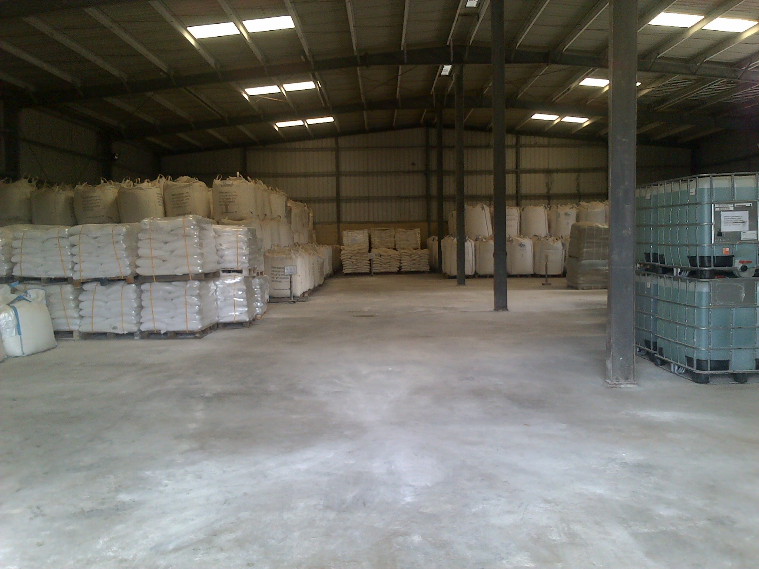

1. **Our certificates**

Omni’s current management system standards and other certificates

* OHSAS 18001 for execution of occupation health and safety



* ISO 9001 for execution of quality assurance



* LEEA for execution of lifting inspection



# **3. Goals and targets for 2016**

* Safety Trainings (minimal 1 safety training per month)
* Toolbox Participation (minimal 1 toolbox per employee per week)
* Hazard Report (minimal 3 hazard reports per employee per year)
* Workplace Inspection (minimal 1 inspection per operational staff per week)
* Drills for Emergency Preparedness (minimal 2 drill per operational site per year)
* Monthly and Yearly HSE Statistics
* Achieve 0 Lost Time Incident (LTI)
* Achieve 0 Environmental Incident
* Internal Audit (minimal 2 audit per year)
* Management Review (minimal 1 management review per year)

1. **HSE Performance** 
   1. **Man days and Hours.**

Man days and hours are important inputs for assessing health and safety performance. It helps to understand the contribution of each staff in terms of man days worked or lost, man hours worked as well as man hours worked without LTIs. These figures are cumulative and form an essential basis for various analytical techniques for drawing year to year comparison and for benchmarking against the performance of other players in the oil and gas industry.

|  |  |
| --- | --- |
| **Man Days & Hours as at 30th June 2016** |  |
| Max of Number of Staff | 66 |
| Sum of Man Days Worked | 515 |
| Sum of Man Days Lost (days lost per LTI) | 3 |
| Sum of Man Hours Worked (8 hrs.) | 68,904 |
| Sum of Man Hours Worked without LTI | 68,624 |
| Sum of Man Hours Lost from LTI (8 hrs. per lost days) | 24 |

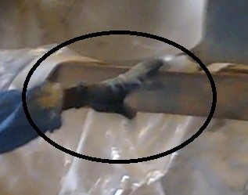

**Slings Fabrication Unit**

**Ghana Warehouse**

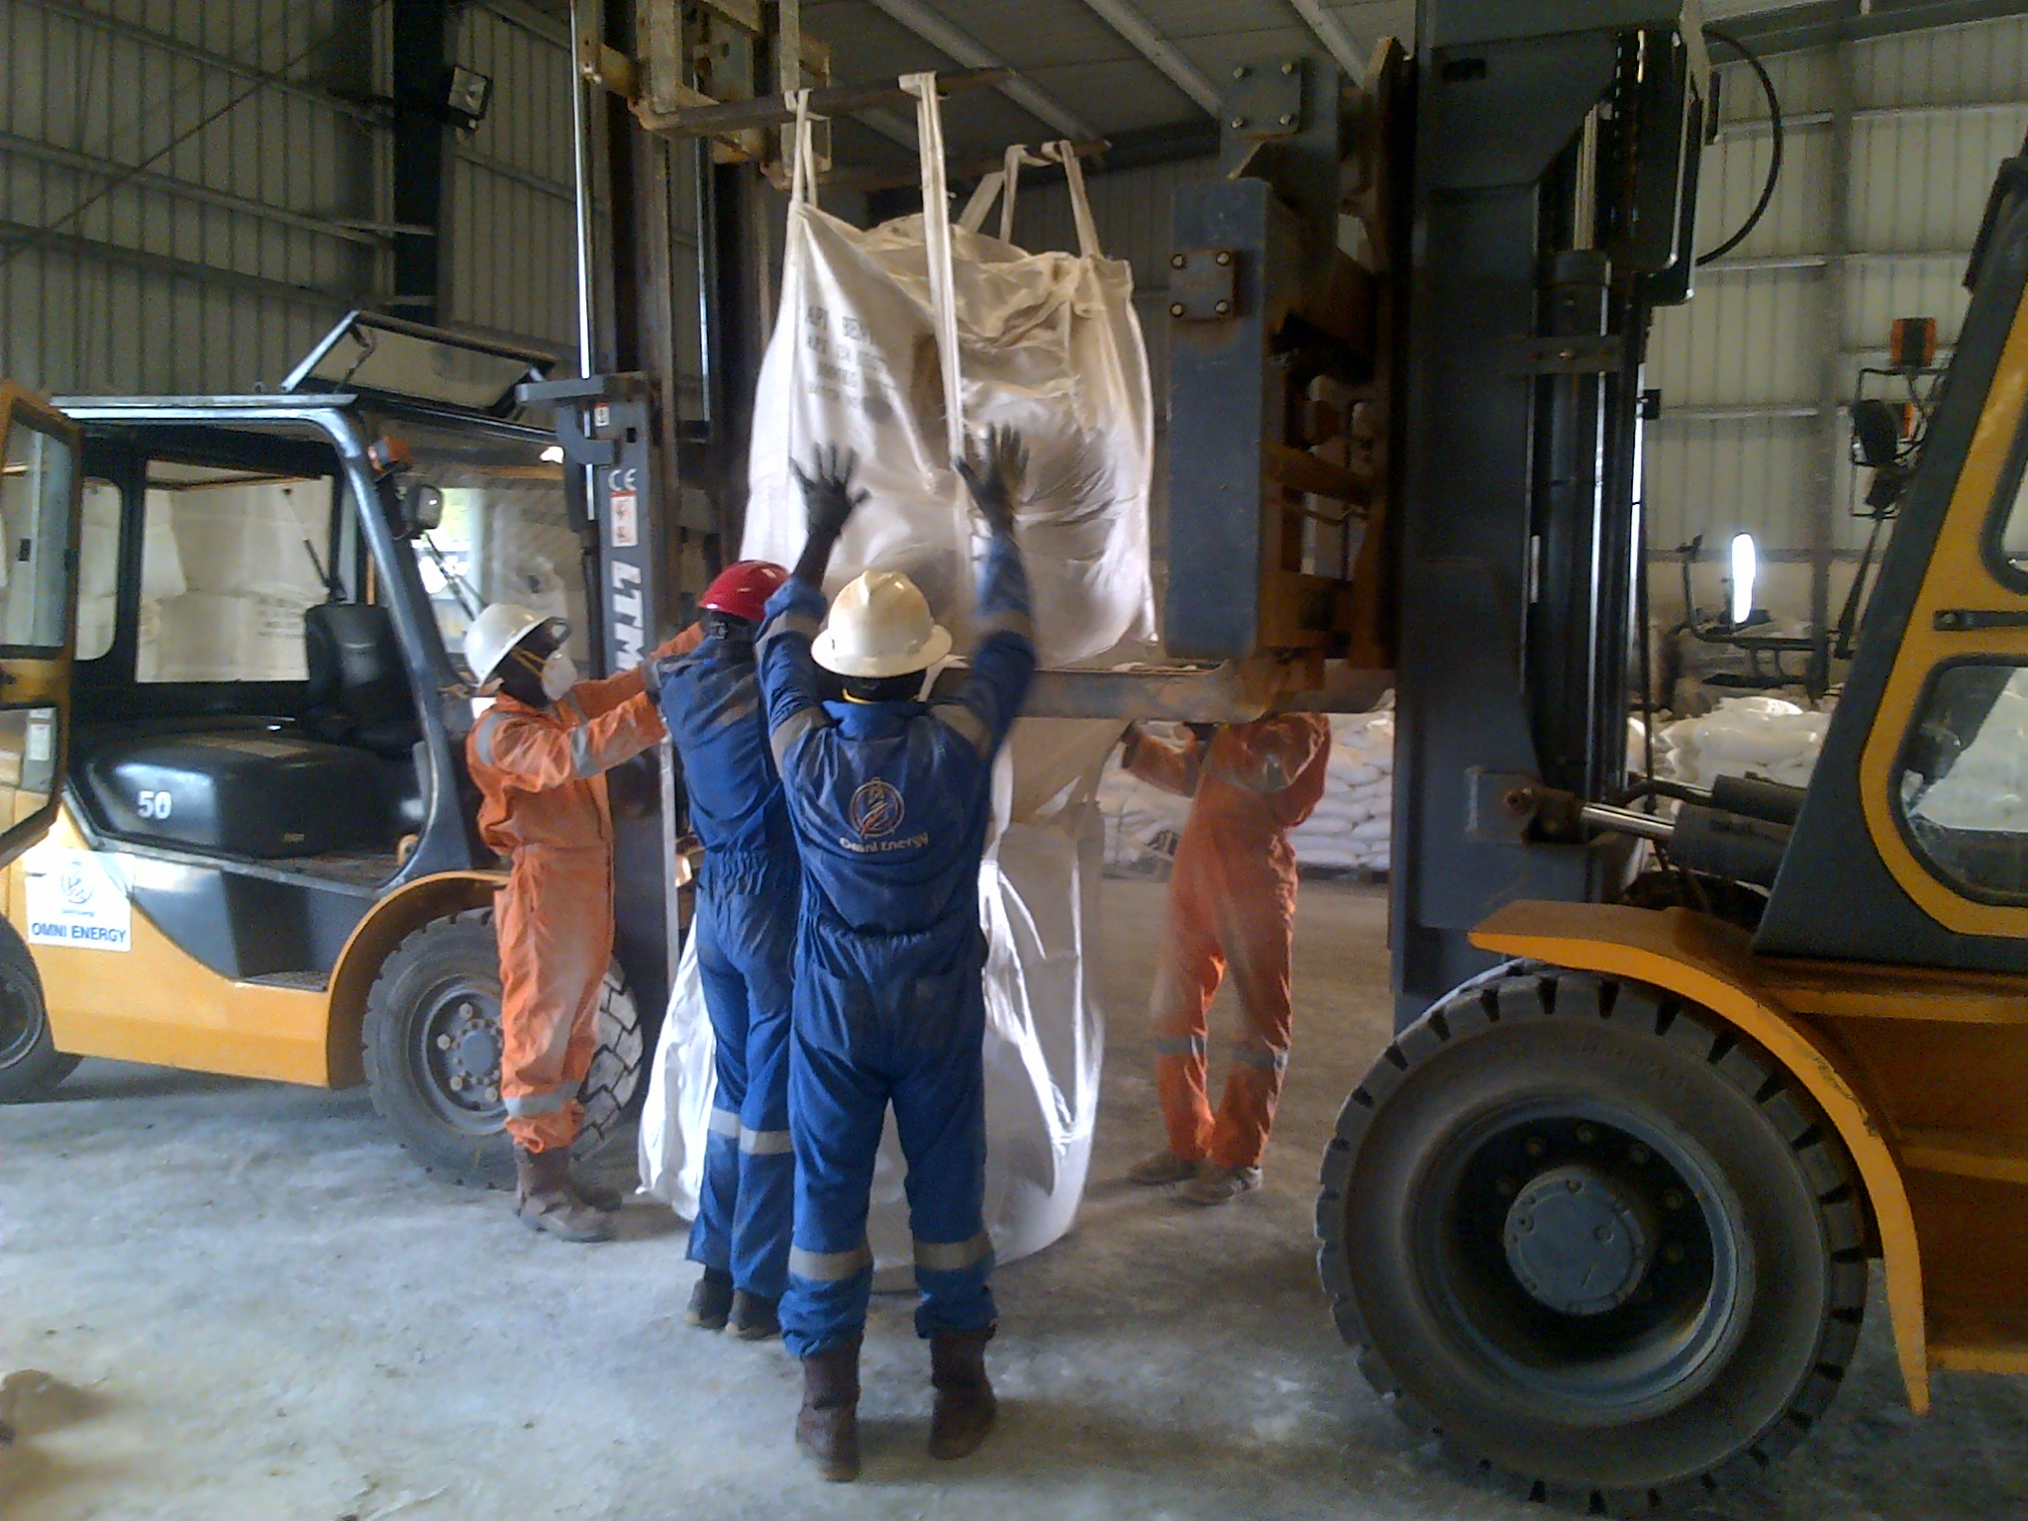

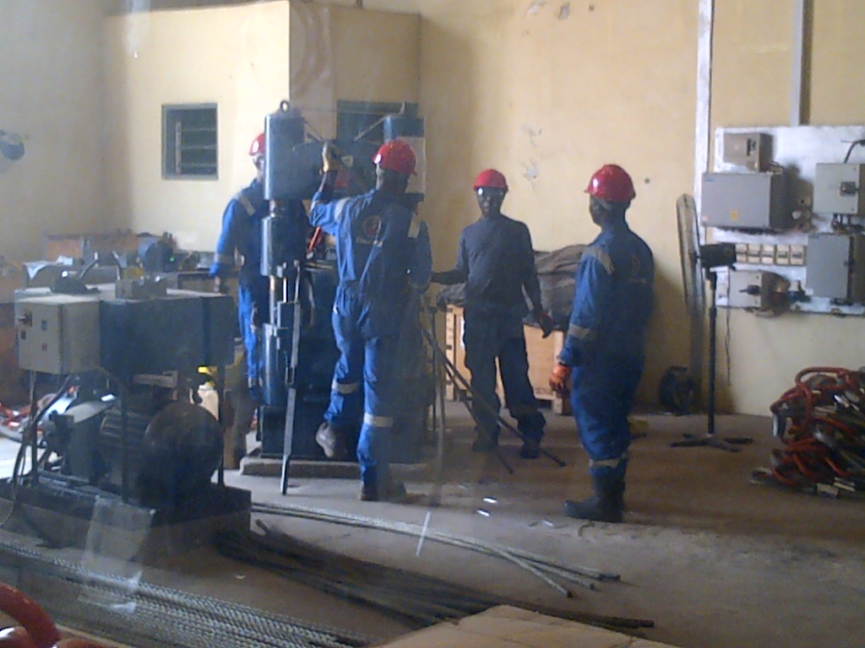

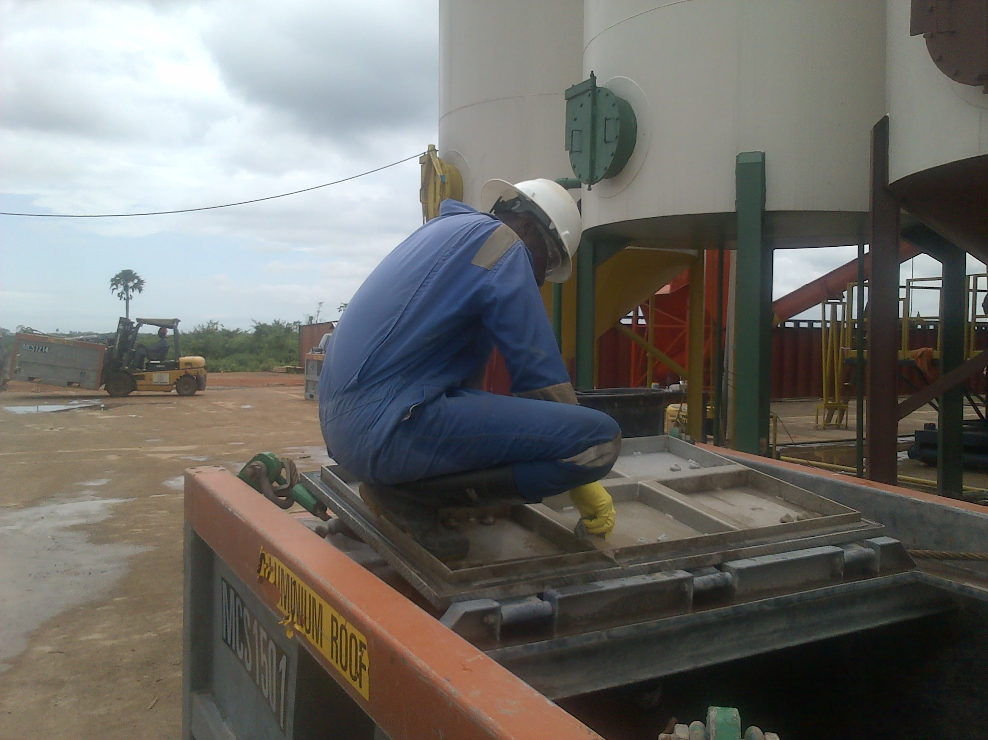

**Man Hours Worked without LTI = 68,624**

**Thermal Desorption Plant**

* 1. **Lagging Indicators**

The table below present specific indicators for assessing the failures in Omni’s health and safety management system for trend analysis and to instigate effective controls to prevent such failures from reoccurring. Of all the lagging indicators, Medical Treated Incident recorded the highest, implying that there have been many cases of staff visiting the hospital in the period under review.

|  |  |
| --- | --- |
| **Lagging Indictors** |  |
| Sum of No. of First Aid Cases (FAC) | 5 |
| Sum of No. of Medical Treated Incident (MTI) | 12 |
| Sum of No. of Lost Time Incidents (LTI) | 2 |
| Sum of No. of Fatal accidents | - |
| Sum of No. of Near Miss (NM) | 4 |
| Sum of Property Damage | 6 |

**Medical Treated Incident remains the highest (12)**

* 1. **Leading Indicators**

Health and safety performance can be demonstrated based on these few leading indicators which helps to prevent failures and deficiencies in the management system

|  |  |
| --- | --- |
| **Leading Indicators** |  |
| Sum of No. of Induction Trainings | 2 |
| Sum of No. of Monthly Training | 9 |
| Sum of Job Specific Training | 10 |
| Sum of No. of Hazard Report | 7 |
| Sum of No. of Weekly Toolbox | 33 |
| Sum of No. Internal Audit | - |
| Sum of No. of Workplace Inspection | 538 |
| Sum of No. emergency Drills | 2 |

**Workplace inspection recorded the highest figure of 538**

* + 1. **Workplace Inspection**

Workplace inspection is the highest leading indicator, recording a grand total of 538 inspections in the period under review. Comparative analysis by country, shows the highest inspection regime in Ghana, followed by Cameroon IVC and Congo. HSE department appreciate the effort all safety representatives for such tremendous contribution.

|  |  |
| --- | --- |
| **Row Labels** | **Sum of No. of Workplace Inspection** |
| Cameroon | 149 |
| Congo | 43 |
| Ghana | 288 |
| IVC | 58 |
| **Grand Total** | **538** |

**Ghana recorded the highest number of workplace inspection of 288**

* + 1. **Workplace Inspection (month by month)**

A comparative study of inspection records by month shows an improving trend, even though it took a downswing in March. The reason was due to low level of supervision from the HSE department. However, there has been a consistent upswing from April to June because workers participation has gradually improved.

|  |  |
| --- | --- |
| **Row Labels** | **Sum of No. of Workplace Inspection** |
| Jan | 79 |
| Feb | 85 |
| Mar | 59 |
| Apr | 81 |
| May | 96 |
| Jun | 138 |
| **Grand Total** | **538** |

**June recorded the highest number of workplace inspection of 138**

* + 1. **Monthly Training**

Training is noted to be an important aspect of behavioral based safety focused on improving safety attitudes of workers and the safety culture of Omni. Topic treated included; emergency procedure, fire safety, electrical safety, substance abuse at work, among many others. Attendance for monthly training was recorded to ensure all staff participated in the training. March recorded the highest attendance. The sharp decline in April is attributed to only 1 training carried out at Takoradi Base, instead of other branches on Omni.

|  |  |
| --- | --- |
| **Row Labels** | **Sum of No. of Attendant per Monthly training** |
| Jan | 17 |
| Feb | 22 |
| Mar | 39 |
| Apr | 11 |
| May | 37 |
| Jun | 34 |
| **Grand Total** | **160** |

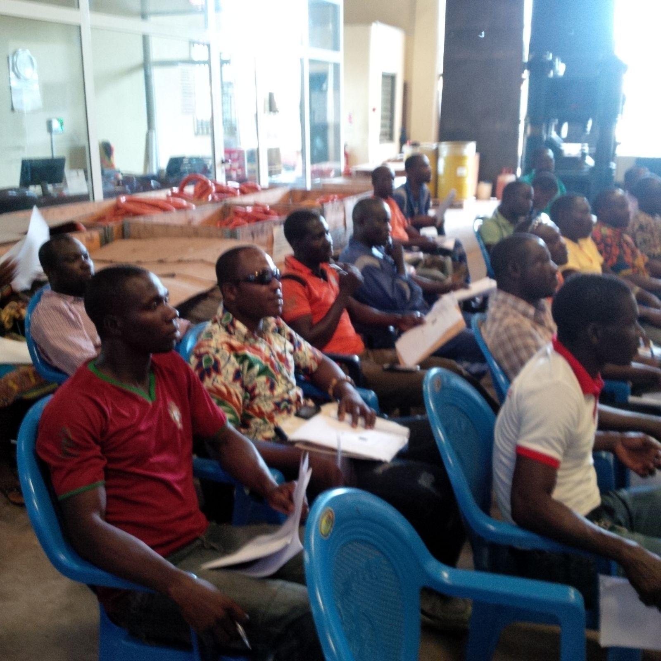

* + 1. **Job Specific Training**

A total of 10 job specific training was conducted at the Sling Fabrication Unit to improve the competence of staff in the department. Competence of staff is key for accident prevention. This helps to reduce human failures leading up to accidents. HSE department encourages that more job specific training is carried out at all Omni branches to improve human reliability in job performance.

* + 1. **Toolbox Talks Participation**

Toolbox participation by staff has been deemed important for workers to make contributions and be consulted on health and safety issues. Toolbox is done on weekly basis, mostly at operational bases such as the Slings Unit, TDU and Warehouse. This leveled in January and February, Plateaued in May and dropped in June. We entreat other branches of Omni to embrace the concept of toolbox talks on weekly basis.

|  |  |
| --- | --- |
| **Row Labels** | **Sum of No. of Toolbox Participation** |
| Jan | 15 |
| Feb | 15 |
| Mar | 20 |
| Apr | 12 |
| May | 24 |
| Jun | 12 |
| **Grand Total** | **98** |

* + 1. **Hazard reporting**

A total of 7 Hazards were reported in the period under review. This figure is significantly low considering the scale of operations of Omni. Less reporting of hazards implies workers don’t see hazard reporting as their responsibility or see hazards as a normal working condition. HSE department entreat all staff to report at least 3 hazards in the year.

* 1. **Accident and Incident Rate**

These are based on Injury Frequency Rate, Lost Time Injury Frequency Rate and Incident Severity Rate to analyze accidents and incident over the period under review. The results are used for comparative analysis.

|  |  |
| --- | --- |
| **Injury Frequency Rate** |  |
| Sum of Man Hours Worked (8 hrs.) | 68,904 |
| Sum of No. of Lost Time Incidents (LTI) | 2 |
| Sum of No. of Medical Treated Incident (MTI) | 12 |
| Sum of No. of First Aid Cases (FAC) | 5 |
| Sum of No. of Fatal accidents | - |
|  | 55.1 |

|  |
| --- |
| **IFR** (Injury Frequency Rate): I.e. (Reportable Accidents X 200,000) / Total Man hours worked (Own + Contract) Injury Frequency Rate measures the number of injury per 200,000 man hours worked over a define period of time. |
|
|
|
|

This result implies that 55 injuries will occur for 200,000-man hours worked by currently staff of 66

|  |  |
| --- | --- |
| **Lost Time Injury Frequency Rate** |  |
| Sum of No. of Lost Time Incidents (LTI) | 2 |
| Sum of Man Hours Worked (8 hrs.) | 68,904 |
|  | 5.81 |

|  |
| --- |
| **LTIFR** (Lost Time Injury Frequency Rate): I.e. (LTI X 200,000) / Total Man hours worked (Own + Contract) Lost Time Injury Frequency Rate is the number of LTIs per 200,000 man hours worked |
|
|
|
|

The result implies that 6 LTIs shall be recorded for 200,000 man-hours worked by current staff of 66

|  |  |
| --- | --- |
| **Injury Severity Rate** |  |
| Sum of Man Days Lost (days lost per LTI) | 3 |
| Sum of Man Hours Worked (8 hrs.) | 68,904 |
|  | 8.71 |

|  |
| --- |
| **ISR (Injury Severity Rate):** I.e. (No. of Man Days Lost X 200,000) / Total Man hours worked Injury Severity Rate is the man days lost per 200,000 man hours worked. |
|
|
|
|

The result implies that 9 man days shall be lost for 200,000 man hours worked by current staff of 66

It reveals how critical the injuries and illnesses are, since employee who takes time to return to work after injury have a more severe problem than those who can return to work immediately.

1. **Environment**

HSE department seeks to minimize environmental incidents to the barest minimum. Severe environmental incident are those that involve restoration cost. Only 2 minor incidents were recorded in the period under review. These minor incidents were lost of containments (i.e. torn chemical sacks) during offloading activities. These spills were quickly shoveled up for repackaging whiles those which mixed up with sand were disposed of as hazardous waste.

|  |  |  |  |  |  |  |
| --- | --- | --- | --- | --- | --- | --- |
| **Environmental Incidents** | | | | | | |
| Type of Environmental Incident | January | February | March | April | May | June |
| Severe Environment Incident | 0 | 0 | 0 | 0 | 0 | 0 |
| Minor Environment Incident | 0 | 0 | 0 | 1 | 1 | 0 |

1. **Health and Safety Communication**

In order to ensure effective communication, the HSE department continuously engages and consults with workers directly on all safety arrangement.

Communication methods used by the HSE department are as follows:

* Safety inductions
* Peer group discussions
* Notices and posters
* Safety signs
* Toolbox talks/Safety briefings
  1. **Safety induction**

These are brief introductory sessions given to new workers and visitors about the nature of workplace hazards and available controls. During such sessions, the responsible person for the site communicates Omni’s safety policy, hazards and controls as well as the location of escape routes, fire alarms, emergency assembly point and fire extinguishers that have been put in place to deal any foreseeable fire emergency. A total of **5** workers were inducted in the period under review.

* 1. **Peer group discussions**

Peer group discussions are encouraged among workers to provide an informal platform for safety discussions. This enabled workers to raise any workplace concern which affected their health, safety and welfare to the HSE department.

* 1. **Notices and Posters**

Notice boards have been mounted at all sites to keep workers informed. Notices ranges from Omni’s safety policies (HSEQ, Drug and Alcohol, Injury Management), emergency response plans as well as safety training topics and other informative posters are put up on the notices to serve as constant reminders to workers.

* 1. **Safety signs**

Safety signs ranging from warning signs (yellow), prohibition signs (red), safety condition (green) and mandatory signs (blue) were pasted at vantage workplace locations to communicate site standard rules regarding unauthorized entry, use of PPE, precautions to take as well as safe use of an equipment or workplace location.

* 1. **Toolbox talks/Safety briefings**

Toolbox talks was the second highest indicator. These are face to face discussions conducted weekly to create health and safety awareness and enhance staff participation in health and safety arrangement. Safety briefings are sent to all workers via mail. Some of the areas covered by the total box talks are as follows: Hazards associated with cell phone usage, personal safety, chemical handling, electrical hazards, horseplay, fire safety etc.

|  |  |
| --- | --- |
| **Row Labels** | **Sum of No. of Weekly Toolbox /Safety Briefings** |
| Jan | 5 |
| Feb | 6 |
| Mar | 4 |
| Apr | 7 |
| May | 6 |
| zJun | 5 |
| **Grand Total** | **33** |

**End**