**Office Safety**

**Inspection Checklist**

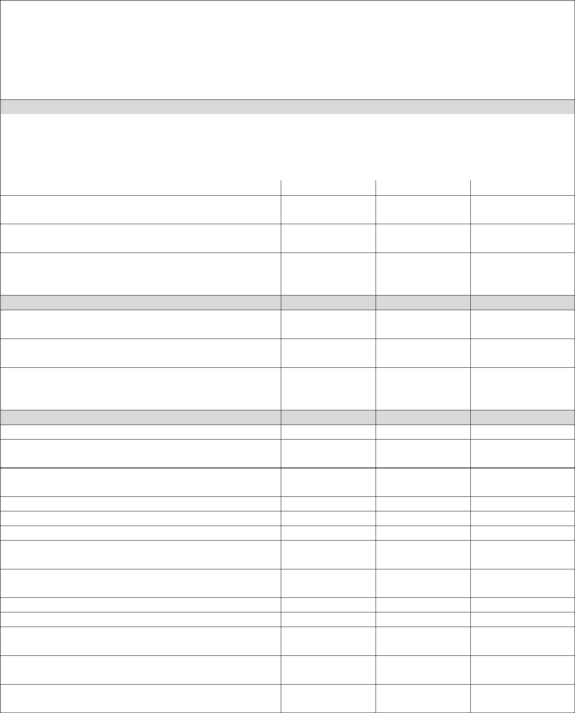

**Instructions:** This checklist addresses responsibilities and possible safety hazards which maybe present in an administrative work location. This form is to be completed by employees who have been trained to perform safety inspections. To complete the checklist, employee interviews and some records review will occur. Upon completion, the form is provided to all managers and supervisors at the work location and one copy is provided to the safety coordinator. For any items checked "Unsatisfactory", an explanation must be provided on an attached sheet. Feel free to edit this form to suit your workplace.

**Inspection Location**

|  |  |  |  |  |  |
| --- | --- | --- | --- | --- | --- |
|  | **Agency** |  | **Organization** |  |  |
|  |  |  |  |  |  |
|  | **Address** |  |  |  |  |
|  |  |  |  |  |  |
|  | **Housekeeping** |  | **Satisfactory** | **Unsatisfactory** | **N/A** |
|  |  |  |  |  |  |

1. Floor and aisles are free of litter and spilled liquids (water, pens, paper, etc.)
2. Aisles are free of cords, boxes, chairs and other tripping hazards
3. Desks or file drawers are closed when not in use and only one drawer is used at a

|  |  |  |  |
| --- | --- | --- | --- |
| time |  |  |  |
| **Ergonomics** | **Satisfactory** | **Unsatisfactory** | **N/A** |

1. All office equipment is being used correctly
2. Employees are properly positioned at their desk and maintain good neutral posture
3. Employees are using their workstation efficiently and avoiding stretching or

|  |  |  |  |
| --- | --- | --- | --- |
| reaching for objects placed far away |  |  |  |
| **Electrical** | **Satisfactory** | **Unsatisfactory** | **N/A** |

1. Electrical devices have manager approval
2. All extension cords are in good condition and are not frayed
3. Extension cords are not being used as permanent wiring

|  |  |  |  |
| --- | --- | --- | --- |
| **Evacuation/Fire** | **Satisfactory** | **Unsatisfactory** | **N/A** |
|  |  |  |  |

1. All aisles are at least 36 inches wide
2. Doors are labeled as exits
3. Exit signs are installed and lit from an internal or external source
4. Doors are not locked to prevent exit from the building
5. Fire doors are not propped open
6. An evacuation plan is posted
7. Fire extinguishers and pull stations are in the locations noted on the evacuation plan
8. Fire extinguishers are identified with signs and not blocked
9. Fire extinguishers appear to be in good condition and have been inspected

|  |  |  |  |  |  |
| --- | --- | --- | --- | --- | --- |
|  | **Other Inspection Items** | | **Satisfactory** | **Unsatisfactory** | **N/A** |
|  | 1. | All areas are well lit and lights are |  |  |  |
|  |  | functioning properly |  |  |  |
|  | 2. | Office equipment is kept at least 18 inches |  |  |  |
|  |  | from electrical cabinets |  |  |  |
|  | 3. | There are no observable drips or water |  |  |  |
|  |  | damage |  |  |  |
|  | 4. | Flooring is in good condition and the |  |  |  |
|  |  | carpets are not ripped and tiles are not |  |  |  |
|  |  | broken or uneven |  |  |  |
|  | 5. | Employees are refraining from unsafe |  |  |  |
|  |  | behaviors (standing on chairs, etc.) |  |  |  |
|  | 6. | Warning signs are posted near hazards |  |  |  |
|  |  | (wet floors, repair work, etc.) |  |  |  |

**Comments:**

|  |  |
| --- | --- |
| **Inspector name(s)** | **Date** |
|  |  |