**Critical Lift Plan**

Person requesting lift: __________________________________ Date ____________

Dept/Div: _____________________________________________

Lift location: ____________________________________________________________

Person in charge of lift: ________________________________________

The person in charge must be present during the entire critical lift and be qualified to answer questions and resolve any problems that might arise during the lifting operation.

Reason for critical lift (check all that apply):

____ Load is greater than 85 percent of mobile crane rated capacity, or greater than 90 percent of

rated fixed crane capacity.

____ Two or more cranes/booms are required or special hoisting/rigging equipment will be used.

____ There is a potential for release of hazardous materials due to collision or upset of load.

____ It poses a high risk of injury or damage to personnel, property, or natural resources due to

location and/or space constraints.

____ Damage would result in excessive costs or delay to the schedule.

____ Other (explain on a separate sheet and attach)

**Crane**

Crane type ________________________ Manufacturer __________________________

Model No. ___________________________ Capacity ___________________________

Max operating wind speed ______________________ (no lifts at more than 25 mph)

Date of last Annual Inspection ________

Date of last calibration of instruments _________

**Operator(s)**

Name ________________________________ Certificate expiration date ____________

Name ________________________________ Certificate expiration date ____________

**Support Personnel**

____ Forklift operator Name(s): _______________________________________

____ Signaler Name(s): _______________________________________

____ Rigger Name(s): _______________________________________

____ Other (specify) ______________________________________________________

**Load Description and Weight**

Item(s) to be lifted: _______________________________________________________

_______________________________________________________________________

***Load Weight Calculations***

Certified weight scale: _________________

Other source/calculation: _______________

Weight: ______________________

Weight: ______________________

Calculation work sheets must be attached to this Plan and have a PE stamp or be signed off by the person in charge.

**Critical Lift Plan (cont’d)**

**Center of Gravity**

Location of center of gravity: ____________________________________________

The center of gravity must be marked onto the load. Attach a drawing that shows how it was determined.

**Rigging Equipment and Attachments**

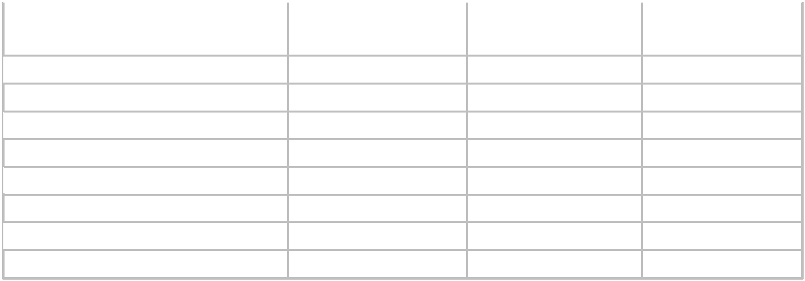

|  |  |  |  |
| --- | --- | --- | --- |
| **Equipment/Attachment** | **Last Date** | **Rated Capacity** | **Weight (lb)** |
|  | **Inspected** | **(lb)** |  |

 Slings

Shackles

 Lifting rings

Eyebolts

 Rigging hooks

Load block/Jib

 Spreader bars

Below the hook lift devices

**Total Weight of Load, Rigging, and Attachments** Calculation source: __________________________

Total Weight: _______________________________

**Relationship of Lifting Equipment to the Load**

Maximum Operating Radius: ____________________________________________

Planned Operating Radius: ______________________________________________

Allowable load at maximum lift radius anticipated (from Load Chart): ___________

Ratio of lift to allowable load: ____________________________________________

Clearance between boom and lift: _________________________________________

Clearance to surrounding facilities/utilities: _________________________________

Clear path for load movement: ___________________________________________

**Ground Area**

Soil-bearing capacity: ____________________ Source: ______________________

Mats required: ________________ Size and number: ________________________

Underground utilities location: __________________________________________

Ratio of soil-bearing capacity to actual: ___________________________________

**Lifting Operation**

Attach a detailed drawing to scale showing the Set-Up Area, Lifting Area, Load Placement Area, and Sling Attachment Points w/sling angle reduction factor.

**Critical Lift Plan (cont’d)**

**Lift Approval Signatures**

____________________________________________

Professional Engineer/ Qualified Person

_______________________________________________

Person in Charge (PIC) (Critical Lift)

_______________________________________________

Operator of Equipment (Critical Lift)

________________________________________________

Responsible Manager or Designee

**Pre-Lift Meeting**

Date: _________Time: _________ Location: ____________________________

**Critical Lift Plan (cont’d)**

**Rigging Sketch**

Sketch the rigging configuration and identify the following:

* Lift points
* Shackles/swivel eyes
* Slings, sling angles, and sling loads
* Accessories
* Capacities
* Center of Gravity

**Critical Lift Plan (cont’d)**

**Load Path Sketch**

Sketch the load path for limited access or complex lifts.

Include all relevant aspects such as load height, obstructions, and crane speeds.